**MODELING AND ANALYSIS OF SPUR GEAR**

# PROJECT REPORT

Project submitted in partial fulfilment of the degree

BACHELOR OF TECHNOLOGY

IN

MECHANICAL ENGINEERING

Submitted by

|  |  |  |  |  |
| --- | --- | --- | --- | --- |
| E. Adharsha |  |  |  | ID NO-O180645 |
| Y. Sai Mahesh |  |  |  | ID NO-O180846 |
| M. Immaniyelu |  |  |  | ID NO-O180036 |
| K. Dhana Lakshmi |  |  |  | ID NO-O180429 |
| K. Ayyappa Swamy |  |  |  | ID NO-O180587 |

Under the supervision of

**R. SANJAY KUMAR,** M. Tech

Assistant Professor



Department of Mechanical Engineering,

Rajiv Gandhi University of Knowledge Technologies,

Ongole Campus,

2023-2024.

# CERTIFICATE

This is to certify that the project report entitled “**MODELING AND**

## ANALYSIS OF SPUR GEAR ” submitted by E. Adharsha, Roll No: O180645, Y. Sai Mahesh, Roll No: O180846, M. Immaniyelu, Roll No: O180036, K. Dhana Lakshmi, Roll No: O180429, K. Ayyappa Swamy, Roll No: O180587, to the Department of Mechanical Engineering, Rajiv Gandhi University of Knowledge Technologies, Ongole Campus, during the academic year 2023-2024 is a partial fulfilment for the award of Undergraduate degree of Bachelor of Technology in Mechanical Engineering, is a bonafide record carried out by them under my supervision. The project has fulfilled all the requirements as per the regulations of this institute and in my opinion reached the standard for submission.

## Dr. Ravichandra D Mr. R. Sanjay Kumar

Head of the Department Assistant Professor

Department of Mechanical Department of Mechanical

RGUKT Ongole Campus RGUKT Ongole Campus

Date:

Place: Ongole

# APPROVAL SHEET

This report entitled “**Modeling and Analysis of Spur Gear**” submitted by E. Aadharsha, Roll No: O180645, Y. Sai Mahesh, Roll No: O180846, M. Immaniyelu, Roll No: O180036, K. Dhana Lakshmi Roll No: O180429, K. Ayyappa Swamy, Roll No: O180587 and it is approved by Mr. R. Sanjay Kumar for the degree of Bachelor of Technology in MECHANICAL ENGINEERING.

Examiner(s)

Supervisor

Chairman

Date:

Place:

# DECLARATION

We declare that this written submission represents our ideas in our own words. We have adequately cited and referenced the original sources. We also declare that We have adhered to all principles of academic honesty and integrity and have not misrepresented or fabricated or falsified any idea/data/fact/source in our submission. We understand that any violation of the above will be cause for disciplinary action by the Institute and can also evoke penal action from the sources which have thus not been properly cited or from whom proper permission has not been taken when needed**.**

Signature

E. Adharsha (0180645)

Y. Sai Mahesh (O180846)

M. Immaniyelu (O180036)

K. Dhana Lakshmi (O180429)

K. Ayyappa Swamy (O180587)

Date:

# ACKNOWLEDGEMENT

I take this opportunity to express my sincere thanks to all those who have been keen interest in directing my efforts towards a successful completion of the major project.

I wish to register my deepest sense of gratitude and respect to my guide **Mr. R. Sanjay Kumar** on his constant support and guidance throughout the duration of the project. The critical analysis and timely suggestion have helped us coming out with this fruitful result.

I wish to thank Head of the Department of Mechanical Engineering **Dr.**  **Ravichandra D** for his support and encouragement. One of the major factors in paving my way through all the difficulties has been in his support and motivation.

At the outset, I would like to thank Rajiv Gandhi University of Knowledge Technologies, Ongole for providing all the necessary resources for the successful completion of my course work. At last, but not least I thank my team members and other students for their physical and moral support.

I also wish to register my feelings towards my family members who have been much more encouraging and understanding.

With Sincere Regards,

E. Adharsha (O180645)

Y. Sai Mahesh (O180846)

M. Immaniyelu (O180036)

K. Dhana Lakshmi (O180429)

K. Ayyappa Swamy (O180587)

**INDEX**

|  |  |  |
| --- | --- | --- |
| **CHAPTER** | **DISCRIPTION** | **PAGE NO** |
|  | CERTIFICATE  APPROVAL SHEET  DECLARATION  ACKNOWLEDGEMENT  ABSTRACT | II  III  IV  V  X |
| **Chapter 1** | INTRODUCTION | 1-10 |
| **1.1**  **1.2**  **1.3**  **1.4**  **1.5**  **1.6** | Introduction  Need of analysis  Types of Gears  Working of spur gear  Advantages and Disadvantages  Applications | 1  1  2  7  8-9  9-10 |
| **Chapter 2** | Literature work | 11-12 |
| **2.1** | Research Papers | 12 |
| **Chapter 3** | Methodology and Design | 13-27 |
| **3.1**  **3.2**  **3.3**  **3.4**  **3.5**  **3.6**  **3.6.1**  **3.6.2** | Introduction  Introduction to CATIA V5  Design procedure for spur gear  Introduction to ANSYS  Simulation in Ansys  Material properties  Specification and Design Calculation  Calculation of gear tooth properties | 13  14-17  17-22  22-23  23  25  25  26 |
| **Chapter 4** | Result and Discussion | 28-29 |
| **Chapter 5** | References | 30-31 |

|  |  |  |
| --- | --- | --- |
| FIGURE NO | DESCRITION | PAGE NO |
| 1.1 | Spur gear | 2 |
| 1.2 | Helical gear | 4 |
| 1.3 | Simple bevel gear | 4 |
| 1.4 | Gear terminology | 6 |
| 3.1 | Model image of spur gear in CATIA V5 | 15 |
| 3.1.1 | Part infrastructure | 18 |
| 3.1.2 | Generative shape design | 18 |
| 3.1.3 | Sketch part | 19 |
| 3.1.4 | Body sketch | 19 |
| 3.1.5 | Circle | 20 |
| 3.1.6 | Object trimming | 20 |
| 3.1.7 | Design pattern | 21 |
| 3.1.8 | 2D Geometry | 21 |
| 3.1.9 | Spur gear designed in CATIA V5 | 22 |
| 3.1.10 | Total deformation | 23 |
| 3.1.11 | Equivalent elastic strain | 24 |
| 3.1.12 | Equivalent stress | 24 |

LIST OF FIGURES

LIST OF TABLES

|  |  |  |
| --- | --- | --- |
| SI.NO | DESCRIPTION | PAGE NO |
| 1 | Simulation result for Cast Iron | 28 |
| 2 | Simulation result for  Aluminium Alloy | 29 |

**ABSTRACT**

Gear is the one of the important machine element in the mechanical power transmission system. Spur gear is most basic gear used to transmit power between parallel shafts. Spur gear generally fails by bending failure. This work analysis of the bending stresses characteristics of an involute spur gear tooth under static loading conditions. The tooth profile is generated using Catia and the analysis is carried out by Finite element method using ANSYS software. The stresses at the tooth root are evaluated by analytically using existing theoretical models. The theoretical and FEM results are compared. The results obtained theoretically are in good agreement with those obtained from software. Also an attempt is made to introduce stress and displacement characteristics of tooth under dynamic loading condition.

**CHAPTER 1**

**INTRODUCTION**

**1.1 BACKGROUND**

Spur gears are the simplest and most common type of gear. Their general form is a cylinder or disk. The teeth project radially, and with these straight-cut gears, the leading edges of the teeth are aligned parallel to the axis of rotation. These gears can only mesh correctly if they are fitted to parallel axles. The torque ratio can be determined by considering the force that a tooth of one gear exerts on a tooth of the other gear. Consider two teeth in contact at a point on the line joining the shaft axes of the two gears. The force will have both a radial and a circumferential component. Gears are a very useful simple machine.

A gear is component within a transmission device. Transmit rotational force to another gear or device. A gear is different from a pulley in that a gear is a round wheel. Mesh with other gear teeth, allowing force to be fully transferred without slippage. Depending on their construction and arrangement, geared devices can transmit forces at different speeds, torques, or in a different direction, from the power source. Gears are a very useful simple machine. The most common situation is for a gear to mesh with another gear, but a gear can mesh with any device having compatible teeth, such as linear moving racks.

**1.2 NEED OF ANALYSIS**

The main purpose of gear mechanisms is to transmit rotation and torque between axes. The gear wheel is a machine element that has intrigued many engineers because of numerous technological problems arises in a complete mesh cycle. In order to achieve the need for high load carrying capacity with reduced weight of gear drives but with increased strength in gear transmission, design, gear tooth stress analysis, tooth modifications and optimum design of gear drives are becoming major research area. Gears with involute teeth have widely been used in industry because of the low cost of manufacturing.

**1.3 TYPES OF GEARS**

## 1.3.1 SPUR GEAR

SPUR GEARS OR STRAIGHT-CUT-GEARSare the simplest type of gear. They consist of a cylinder or disk with teeth projecting radially. Though the teeth are not straight-sided (but usually of special form to achieve a constant drive ratio, mainly involute but less commonly cycloidal), the edge of each tooth is straight and aligned parallel to the axis of rotation. These gears mesh together correctly only if fitted to parallel shafts. No axial thrust is created by the tooth loads. Spur gears are excellent at moderate speeds but tend to be noisy at high speeds.

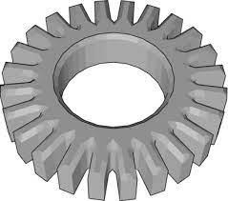

Figure 1.1 spur gear

## 1.3.2 HELICAL GEAR

HELICAL or "dry fixed" gears offer a refinement over spur gears. The leading edges of the teeth are not parallel to the axis of rotation, but are set at an angle. Since the gear is curved, this angling makes the tooth shape a segment of a helix. Helical gears can be meshed in parallel or crossed orientations. The former refers to when the shafts are parallel to each other; this is the most common orientation.

In the latter, the shafts are non-parallel, and in this configuration the gears are sometimes known as "skew gears".

The angled teeth engage more gradually than do spur gear teeth, causing them to run more smoothly and quietly. With parallel helical gears, each pair of teeth first make contact at a single point at one side of the gear wheel; a moving curve of contact then grows gradually across the tooth face to a maximum, then recedes until the teeth break contact at a single point on the opposite side. In spur gears, teeth suddenly meet at a line contact across their entire width, causing stress and noise. Spur gears make a characteristic whine at high speeds. For this reason spur gears are used in low-speed applications and in situations where noise control is not a problem, and helical gears are used in high-speed applications, large power transmission, or where noise abatement is important. The speed is considered high when the pitch line velocity exceeds 25 m/s.

A disadvantage of helical gears is a resultant thrust along the axis of the gear, which must be accommodated by appropriate thrust bearings. However, this issue can be turned into an advantage when using a herringbone gear or double helical gear which has no axial thrust - and also provides self-aligning of the gears. This results in less axial thrust than a comparable spur gear.

A second disadvantage of helical gears is also a greater degree of sliding between the meshing teeth, often addressed with additives in the lubricant.

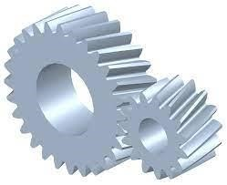

Figure 1.2 helical gear

**1.3.3 BEVEL GEAR**

A bevel gear is shaped like A RIGHT CIRCULAR CONE WITH MOST OF ITS TIP CUT OFF. When two bevel gears mesh, their imaginary vertices must occupy the same point. Their shaft axes also intersect at this point, forming an arbitrary non-straight angle between the shafts. The angle between the shafts can be anything except zero or 180 degrees. Bevel gears with equal numbers of teeth and shaft axes at 90 degrees are called miter (US) or mitre (UK) gears.

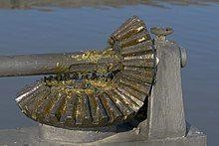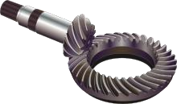

Figure 1.3 Simple bevel gear

**1.3.4 WORM GEAR**

WORMS resemble screws A worm is meshed with a warm wheel which looks similar to a spur gear.

Worm-and-gear sets are a simple and compact way to achieve a high torque, low speed gear ratio. For example, helical gears are normally limited to gear ratios of less than 10:1 while worm-and-gear sets vary from 10:1 to 500:1. A disadvantage is the potential for considerable sliding action, leading to low efficiency.

A worm gear is a species of helical gear, but its helix angle is usually somewhat large (close to 90 degrees) and its body is usually fairly long in the axial direction. These attributes give it screw like qualities. The distinction between a worm and a helical gear is that at least one tooth persists for a full rotation around the helix. If this occurs, it is a 'worm'; if not, it is a 'helical gear'. A worm may have as few as one tooth. If that tooth persists for several turns around the helix, the worm appears, superficially, to have more than one tooth, but what one in fact sees is the same tooth reappearing at intervals along the length of the worm. The usual screw nomenclature applies: a one-toothed worm is called single-thread or single-start. A worm with more than one tooth is called multiple-threads or multiple-start. The helix angle of a worm is not usually specified. Instead, the lead angle, which is equal to 90 degrees minus the helix angle, is given.

In a worm-and-gear set, the worm can always drive the gear. However, if the gear attempts to drive the worm, it may or may not succeed. Particularly if the lead angle is small, the gear's teeth may simply lock against the worm's teeth, because the force component circumferential to the worm is not sufficient to overcome friction. In traditional music boxes, however, the gear drives the worm, which has a large helix angle. This mesh drives the speed-limiter vanes which are mounted on the worm shaft.

Worm-and-gear sets that do lock are called self-locking, which can be used to advantage, as when it is desired to set the position of a mechanism by turning the worm and then have the mechanism hold that position. An example is the machine found on some types of stringed instruments.

If the gear in a worm-and-gear set is an ordinary helical gear only a single point of contact is achieved. If medium to high power transmission is desired, the tooth shape of the gear is modified to achieve more intimate contact by making both gears partially envelop each other. This is done by making both concave and joining them at a saddle point. this is called a cone-drive or "Double enveloping"

Worm gears can be right or left-handed, following the long-established practice for screw threads.

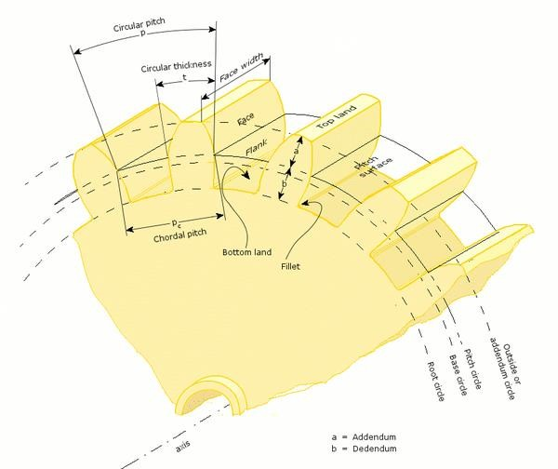

Figure 1.4 Gear Terminology

**1.4 WORKING OF SPUR GEAR**

The most commonly used type of gears is spur gear. Also called straight-cut gears, they have straight teeth that are cut or inserted parallel to the gear’s shaft on a circular gear body. In mated pairs, these gears employ the parallel axes configuration to transmit motion and power. Depending on the application, they can be mated with another spur gear, an internal gear (such as in a planetary gear system), or a gear rack (such as in a rack and pinion gear pair). Their shafts are parallel and coplanar.

The simplicity of the spur gear tooth design allows for both a high degree of precision and easier manufacturability. Other characteristics of spur gears include lack of axial load (i.e., the thrust force parallel to the gear shaft), high-speed and high-load handling, and high-efficiency rates. The lack of an axial load is due to their involute profile. An involute gear profile is the most commonly used gearing system. In an involute gear, the profiles of the teeth are involutes of a circle. An involute is a kind of curve that is dependent on another shape or curve. It is the path taken by the end of an ideal string as it wraps around a curve. Because of this form, spur gears only produce radial forces. An involute gear tooth meshes with another gear at a single point of contact where the involutes meet. The point of contact transfers along the tooth surfaces as the gears turn, and the line of force is tangent to the two base circles. In this way, the gears follow the fundamental law of gearing, which says that the ratio of the gears’ angular velocities must stay constant throughout the mesh.

Some of the disadvantages of spur gears are the amount of stress experienced by the gear teeth and noise produced during high-speed applications. This is why they’re typically only used for lower speed applications, but they can be used for higher speeds if noise is not an issue.

There are two types of spur gears: external and internal. The teeth of the gear are cut on the outside surface of the cylinder that makes up the gear. Two external gears mesh together and rotate in opposite directions. An internal gear’s teeth are cut on the inside surface of their circular form. A smaller external gear sits inside an internal spur gear, and the two or more gears rotate in the same direction. Internal gear assemblies take up less space than external gear assemblies because the shafts can be positioned closer together.

Spur gears can be made from a variety of metals, or plastics such as nylon or polycarbonate. Plastic spur gear create less noise but are not as strong and have less loading capability. Unlike other gear types, spur gears don’t experience high losses due to slippage, so they generally have high transmission efficiency.

**1.5.1 ADVANTAGES**

1. Spur gears are simple components, very easy to design and install in drive mechanisms
2. They are very straightforward and they are ideal for limited spaces.

These gears are suitable for driving systems because they have more power transmission efficiency

1. A spur gear is built with teeth made straight and parallel to the axis of the gear. Eliminating any issue of axial thrust allowing ball bearings to be installed.
2. Spur gears are more efficient compared to helical gears with the same size.
3. They are quite reliable and offer constant velocity.
4. Spur gears are also considered a member of positive transmission because they don’t have any slippage.

**1.5.2 DISADVANTAGES**

1. Mainly because they will produce vibration;
2. No matter because of design, manufacture or deformation, some changes of involute shape may occur along the whole tooth surface at the same time;
3. This leads to a regular, once per tooth stimulation, which is often very strong. The resulting vibration not only causes large load on the gear, but also causes noise;
4. In addition, the additional strength obtained from the engagement of two pairs of teeth in the contact time can not be utilized, because the stress is limited by the engagement of single teeth in the cycle;
5. It can only bear radial load, but not axial load, resulting in unreasonable load distribution, reducing the overall life of the [gearbox](https://www.zhygear.com/tag/gearbox/).

**1.6 APPLICATIONS**

Spur gears are used for a wide range of speed ratios in a variety of mechanical applications, such as clocks, electric screwdrivers, pumps, watering systems, material handling equipment, power plant machinery, and clothes washing and drying machines. If necessary for an application, more than two spur gears can be used in a gear train, which provides higher gear reduction.

They are best used in applications that require speed reduction and torque increase, such as crushing equipment. Spur gears tend to be louder than other types of gears, so they are not generally found in automobiles, but are often used in aircraft engines. Each time a spur gear’s tooth engages with a tooth on another gear, the teeth collide, and this impact makes a noise.

A valve maintenance trailer typically refers to a mobile unit or vehicle equipped with tools and equipment for the maintenance and repair of valves, particularly in industrial settings. These trailers are often used to service valves in pipelines, refineries, chemical plants, and other facilities. They may contain valve testing equipment, valve actuation tools, replacement parts, and safety gear to ensure the proper functioning and safety of valves. The exact equipment and setup can vary depending on the specific maintenance needs and industry requirements.

**CHAPTER 2**

**LITERATURE SURVEY**

**2.1 RESEARCH PAPERS**

## 2.1.1 Seok-Chul Hwanga

He studied the contact stress analysis for a pair of mating gears during rotation. He investigated respective variation of contact stress analysis for helical and spur gear with the different contact position in a pair of mating gears. Compares the variation of contact stresses during rotation at the lowest point of single tooth contact (LPSTC) & the AGMA (American Gear Manufacturers Associated) equation for the contact stress. Select the design that considered the contact stress is stricter than the AGMA Standard. By using FEA analysis calculate the contact fatigue strength of material for the appropriate strength & safety. He carried out FEA analysis using AGMA equations.

## 2.1.2 Pinaknath Dewanji

This paper analyses the bending stresses characteristics of an involute spur gear tooth under static load conditions. The tooth profile is generated using CATIA and analysis is carried out by ANSYS software. The stress at the tooth root are evaluated analytically using existing theoretical models.

## 2.1.3 Anujnath

This paper modeled the spur gear using pro-e software. The impact analysis for cast steel and composite materials are studied. Finally comparing and analysing the composite gears with existing cast steel gear is to be done using ANSYS 13.0.

## 2.1.4 S. Magendran, K.M. Eazhil

This paper modeled the spur gear using solid works software. The weight reduction and stress distribution for cast steel and composite materials are studied. Finally compare and analysing the spur gear using ANSYS software.

## 2.1.5 Devendra Singh

In this paper modeled the spur gear and study about gear drive design and analysis is carried out with the help of pro-e and ANSYS and improve the static and dynamic characteristics of gear drive.

**CHAPTER 3**

**METHODOLOGY AND DESIGN**

**3.1 INTRODUCTION**

In the today’s world of industrialization Gears are the major means for the mechanical power transmission system, and in most industrial rotating machinery. Because of the high degree of reliability and compactness gears dominates the field of mechanical power transmission. Gearbox is used to convert the input provided by a prime mover into an output required by end application. Due to increasing demand for quiet and long-term power transmission in machines, vehicles, elevators and generators, people are looking for a more precise analysis method of the gear systems. Spur gear is the most basic gear used to transmit power between two parallel shafts with almost 99% efficiency. It requires the better analysis methods for designing highly loaded spur gears for power transmission systems that are both strong and quiet. Due to development of computers people are using numerical approach for the analysis purpose as it can give more accurate analysis results. The finite element method is capable of providing information on contact and bending stresses in gears, along with transmission errors, which can be done easily in ANSYS software. Gear analysis in the past was done by using analytical methods which requires complicated calculations. Now with the use of FEA we can calculate the bending stresses in the gear tooth for given loading condition and we can compare the FEA results with existing models to decide the accuracy. Also static as well as dynamic, both loading conditions of gear can be easily analysed in Ansys which is not the case with Analytical method.

**3.2 INTRODUCTION TO CATIA V5**

CATIA (an acronym of Computer-aided three-dimensional interactive application) is a multi- platform software suite for computer-aided design (CAD), computer-aided manufacturing (CAM), computer-aided engineering (CAE), 3D modelling and product life cycle management (PLM), developed by the French Company Dassault Systems**.**

Since it supports multiple stages of product development from conceptualization, design and engineering to manufacturing, it is considered a CAX software and it sometimes referred to as a 3D product life cycle management software suite. Like most of its competition it facilitates collaborative engineering through an integrated cloud service and have support to be used across discipline including surfacing and shape design, electrical, fluid and electronic systems design, mechanical engineering and systems engineering.

Besides, being used in a wide range of industries from aerospace and defence to packaging design, CATIA has been used by architect Frank Gehry to design some of his signature curvilinear buildings and his company Gehry technologies was developing their digital project softwares based on CATIA.

The software has been merged with the company’s other software suite 3D XML layer to form the combined solid works composer layer.

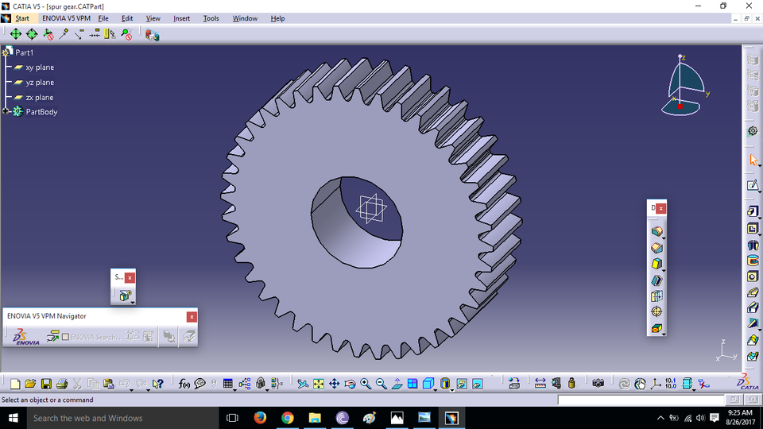

Figure 3.1 model image of spur gear in CATIA V5

The Sketcher workbench is a set of tools that helps you create and constrain 2D geometries. Features (pads, pockets, shafts, etc...) may then be created solids or modifications to solids using these 2D profiles. You can access the Sketcher workbench in various ways. Two simple ways are by using the top pull down menu (Start – Mechanical Design – Sketcher), or by selecting the Sketcher icon. When you enter the sketcher, CATIA requires that you choose a plane to sketch on. You can choose this plane either before or after you select the Sketcher icon. To exit the sketcher, select the Exit Workbench icon.

The Sketcher workbench contains the following standard workbench specific

Toolbars.

**Profile toolbar**: The commands located in this toolbar allow you to create simple geometries (rectangle, circle, line, etc...) and more complex geometries (profile, spline, etc...).

**Operation toolbar**: Once a profile has been created, it can be modified using commands such as trim, mirror, chamfer, and other commands located in the Operation toolbar.

**Constraint toolbar**: Profiles may be constrained with dimensional (distances, angles, etc...) or geometrical (tangent, parallel, etc...) constraints using the commands located in the Constraint toolbar.

**Sketch tools toolbar**: The commands in this toolbar allow you to work in different modes which make sketching easier.

**User Selection Filter toolbar**: Allows you to activate different selection filters.

**Visualization toolbar**: Allows you to, among other things to cut the part by the sketch plane and choose lighting effects and other factors that influence how the part is visualized.

**Tools toolbar**: Allows you to, among others other things, to analyse a sketch for problems, and create a datum.

**The Sketch tools Toolbar**:

The Sketch tools toolbar contains icons that activate and deactivate different work modes. These work modes assist you in drawing 2D profiles. Reading from left to right, the toolbar contains the following work modes; (Each work mode is active if the icon is orange and inactive if it is blue.)

**Grid:** This command turns the sketcher grid on and off.

**Snap to Point**: If active, your cursor will snap to the intersections of the grid lines.

**Construction / Standard Elements**: You can draw two different types of elements in CATIA a standard element and a construction element. A standard element (solid line type) will be created when the icon is inactive (blue). It will be used to create a feature in the Part Design workbench. A construction element (dashed line type) will be created when the icon is active (orange). They are used to help construct your sketch, but will not be used to create features.

**Geometric Constraints:** When active, geometric constraints will automatically be applied such as tangencies, coincidences, parallelisms, etc...

**Dimensional Constraints:** When active, dimensional constraints will automatically be applied when corners (fillets) or chamfers are created, or when quantities are entered in the value field. The value field is a place where dimensions such as line length and angle are manually entered.

**3.3 DESIGN PROCEDURE OF SPUR GEAR**

When an icon is selected, it turns orange indicating that it is active. If the icon is activated with a single mouse click, the icon will turn back to blue (deactivated) when the operation is complete. If the icon is activated with a double mouse click, it will remain active until another command is chosen or if the Esc key is hit twice.

The spur gear modelling was done by using CATIA software based on spur gear design calculation and modelling diagram.

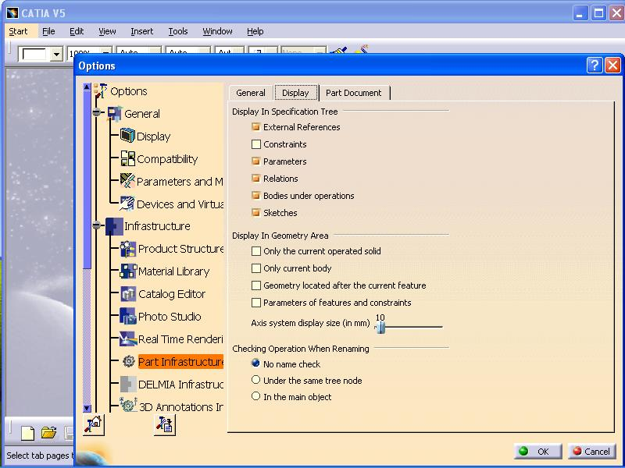

Figure 3.1.1part infrastructure

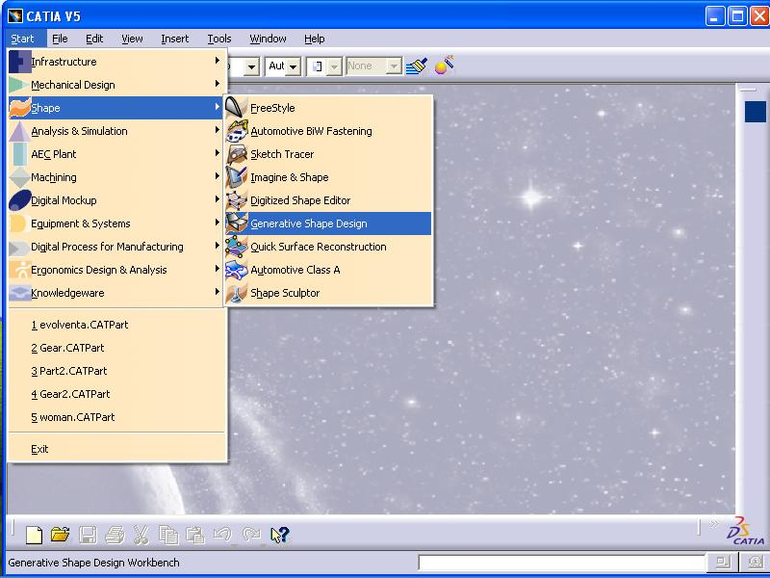

Figure 3.1.2 Generative shape design

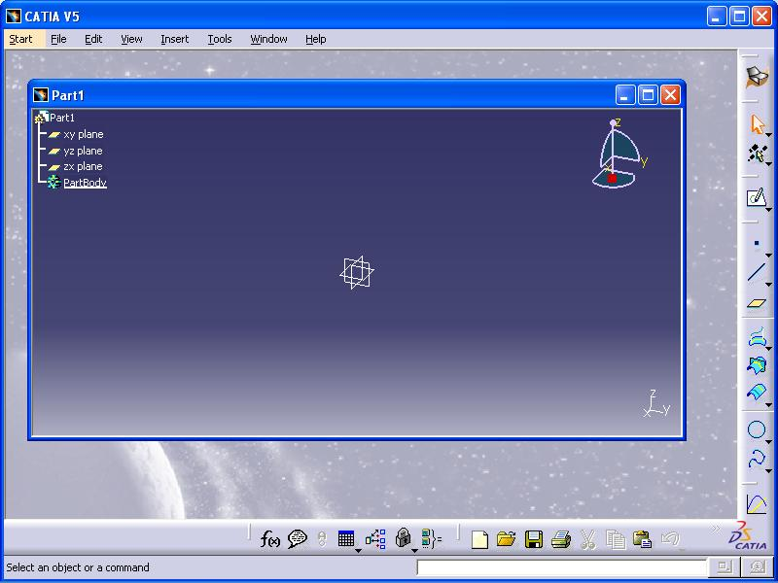

Figure 3.1.3 Sketch part

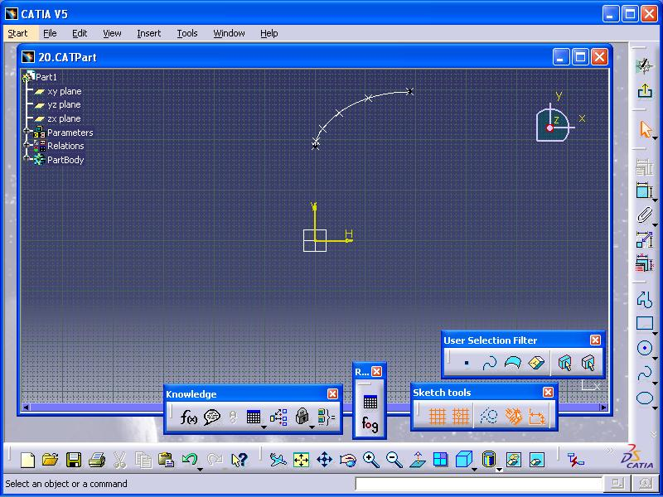

Figure 3.1.4 Body Sketch

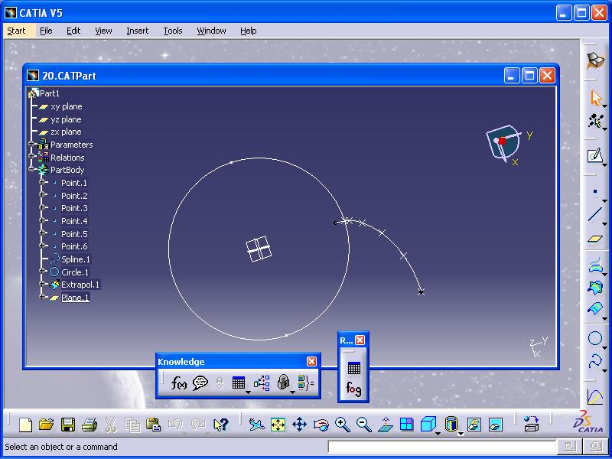

Figure 3.1.5 Circle

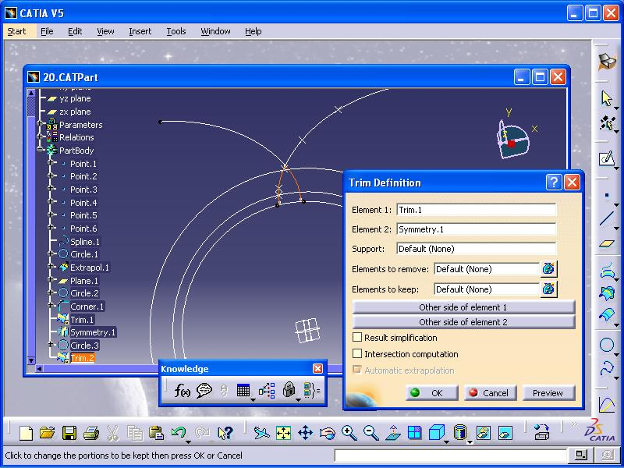

Figure 3.1.6 Object Trimming

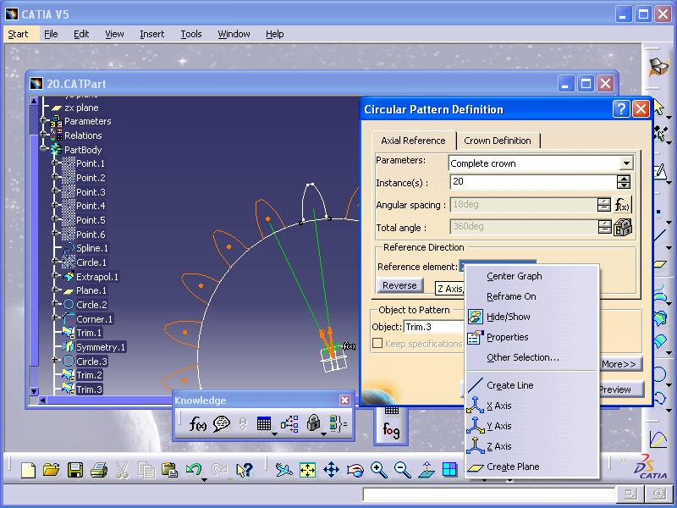

Figure 3.1.7 Design Pattern

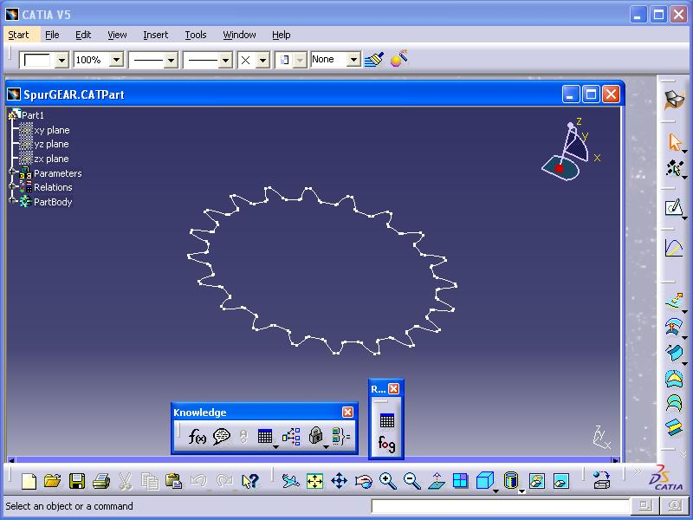

Figure 3.1.8 2D Geometry

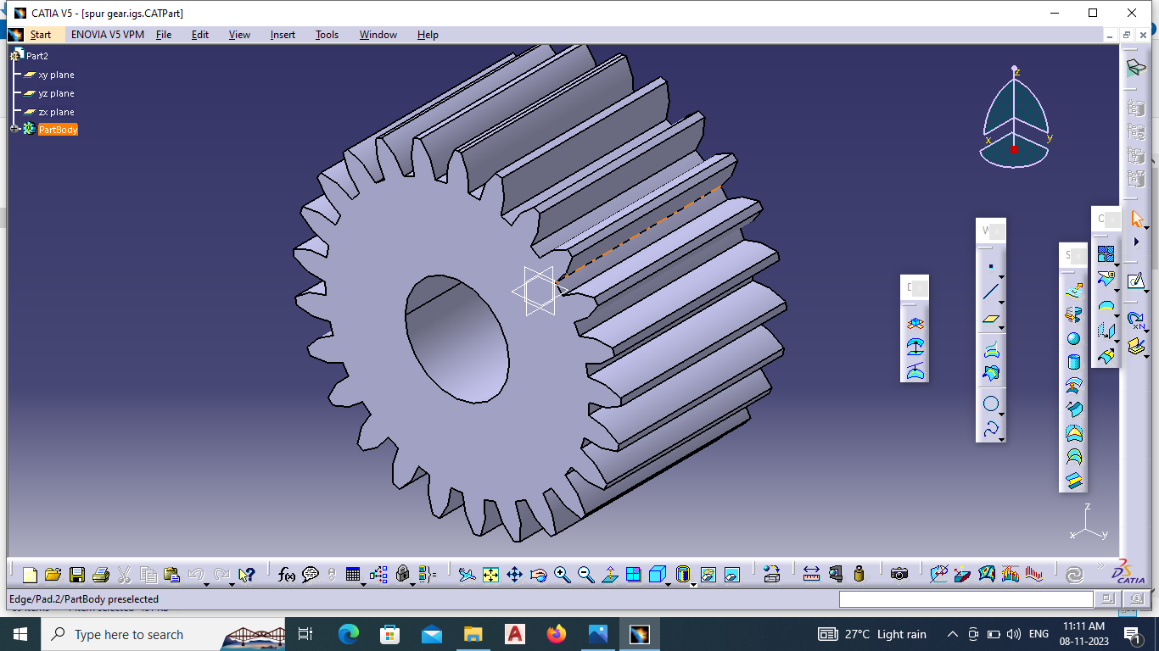

Figure 3.1.9 Spur Gear designed in CATIA V5

**3.4 INTRODUCTION TO ANSYS**

ANSYS is one of the best analysis and simulation software used to simulate [engineering](https://enggkatta.com/category/engineering/)solutions. ANSYS 2.0 was released as the first version in the year of 1971. ANSYS simulates 3d models or structures or machine parts designs to stress, strength, temperature distribution, thermal conductivity, elasticity, fluid flow, air flow, etc. Most of the analysis performed in an ANSYS APDL and simulations into ANSYS Workbench, which are one of the main products.

Ansys Mechanical is a finite element analysis (FEA) software used to perform structural analysis using advanced solver options, including linear dynamics, nonlinearities, thermal analysis, materials, composites, hydrodynamic, explicit, and more.

Ansys offers a comprehensive software suite that spans the entire range of physics, providing access to virtually any field of engineering simulation that a design process requires. Organizations around the world trust Ansys to deliver the best value for their engineering simulation software investment.

**3.5 SIMULATION IN ANSYS**

Ansys offers a comprehensive software suite that spans the entire range of physics, providing access to virtually any field of engineering simulation that a design process requires. Organizations around the world trust Ansys to deliver the best value for their engineering simulation software investment.

Ansys mechanical finite element analysis software is used to simulate computer models of structures, electronics, or machines components for analysing the strength, toughness, elasticity, temperature distribution, electromagnetism, fluid flow, and other attributes.

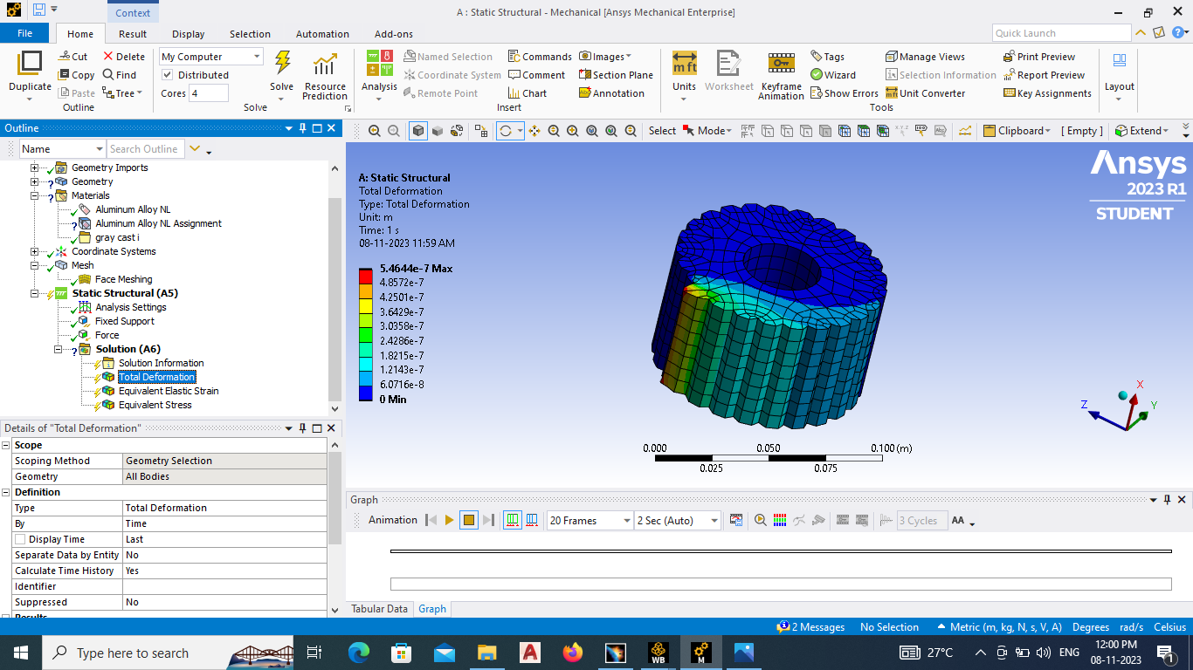

Figure 3.1.10 Total Deformation

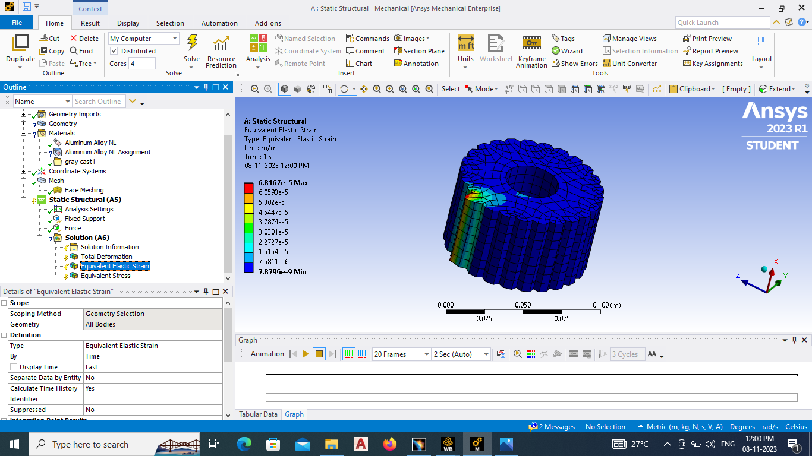

Figure 3.1.11 Equivalent Elastic strain

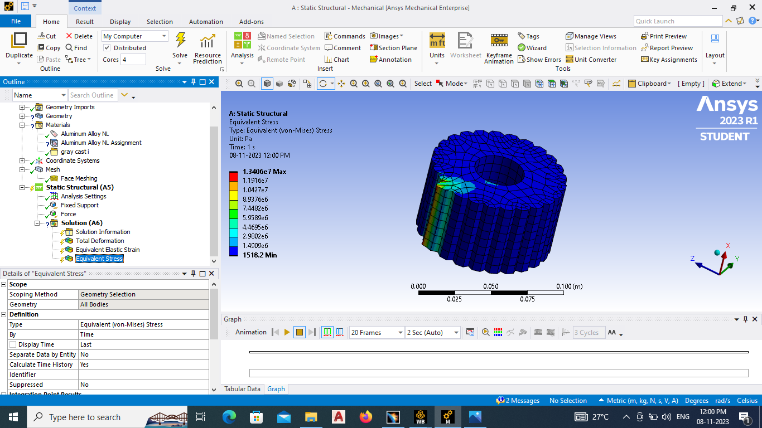

Figure 3.1.12 Equivalent stress

**3.6 MATERIAL PROPERTIES  
Aluminium Alloy**

Aluminium alloys with a wide range of properties are used in engineering structures. Alloy systems are classified by a number system (ANSI) or by names indicating their main alloying constituents (DIN and ISO). Selecting the right alloy for a given application entails considerations of its tensile strength, density, ductility, formability, workability, weldability, and corrosion resistance, to name a few. A brief historical overview of alloys and manufacturing technologies is given in Ref. [4] Aluminium alloys are used extensively in aircraft due to their high strength-to-weight ratio. Pure aluminium metal is much too soft for such uses, and it does not have the high tensile strength that is needed for building airplanes and helicopters.

**3.6.1 SPECIFICATION AND DESIGN CALCULATION**

Model = VMT (valve maintenance trailer)

Engine = 1198

Engine capacity = 1497cc

Maximum engine output = 117hp@6600 rpm

Maximum engine torque = 145 Nm @4600 rpm

Fuel tank capacity = 35 litres

Tyre size = 175/65 R1482T

Wheel base =2345 mm

Width =1680 mm Length = 3610mm

Height =1500 mm

**Calculation:**

Torque (T) = 145000 N-mm Speed (N) = 4600 rpm Power (P) =2*3.14*N*

= 2*3.14*4600*

= 69.812watt Torque (T) = F* d/2

D = z*m

=25*3.5

= 87.5 mm

F = T ⁄ (D/2)

= 145000/43.75

=3314.28 N

The Maximum allowable stress = 8.7413 N/mm^2

Ultimate tensile strength for cast steel = 540mpa

Ultimate tensile strength for composite = 52map

Allowable stress for cast steel = ultimate tensile strength/3

= 540/3 = 180N/mm^2 > 8.74134 N/mm^2

Allowable stress for composite = ultimate tensile strength/3 =52/3 N/mm^2 >8.7413 N/mm^2

So, the design is safe.

**3.6.2 CALCULATION OF GEAR TOOTH PROPERTIES**

Pitch circle diameter =z*m = 25*3.5 =87.5 mm

Basic circle diameter = D*cos20

= 87.5*cos20

=82.145mm

Outside circle diameter =(z+2) *m = (25+2) *3.5 =94.5mm

Clearance = circular pitch/20 = 31.4/20 =1.57mm

Module =D/Z =87.5/25 =3.5mm

Thickness of the tooth =1.571*10 =15.71mm

Face width (b) = 0.3*87.5 =54mm

Centre distance between two gears =180mm

Pitch circle diameter (pc) =m*z = 3.5*25 =87.50mm

dedendum =addendum + clearance =10 + 1.57 = 11.57mm.

diametral pitch =number of teeth/ pitch circle diameter

= 25/87.5 =0.28mm.

**CHAPTER 4**

**RESULTS AND DISCUSSION**

In this project, the spur gear designed and modelled using 3D parametric software CATIA. And also the analysis has been performed by using ANSYS in a general purpose finite element analysis (FEA) software package. To validate the strength of the model, the structural analysis on the spur gear has been carried out by varying different gear materials by Cast Iron and Aluminium Alloy analysis is done to determine the total deformation, equivalent elastic strain, equivalent stress.

Table 4.1 Simulation Result

|  |  |  |  |
| --- | --- | --- | --- |
| **SL.NO** | **CAST IRON** | **Maximum** | **Minimum** |
| 1 | Total  Deformation | 0.010307 | 0 |
| 2 | Equivalent elastic strain | 2.39 | 9.765611e-7 |
| 3 | Equivalent stress | 179.2 | 6.11679 |

|  |  |  |  |
| --- | --- | --- | --- |
| **SL.NO** | **Aluminium Alloy** | **Maximum** | **Minimum** |
| 1 | Total Deformation | 0.010307 | 0 |
| 2 | Equivalent elastic strain | 2.35 | 7.8796e-9 |
| 3 | Equivalent stress | 134.6 | 5.98679 |

Table 4.2 simulation Result

**CHAPTER 5**

**CONCLUSION**

Experimental results from the spur gear under moment are listed in the table. Analysis have been carried out by optimizing the material such as Aluminium Alloy. The result such as total deformation, equivalent elastic strain and equivalent stress for each material are determined. Comparing the optimized materials and the conventional material. Aluminium alloy material has the low values of total deformation, stress and strain. Hence it is the concluded that Aluminium alloy material is the suitable for the spur gear manufacturing.

**REFERENCES**

1. Seok-Chul Hwanga, Department of Mechanical Engineering, Dong-A university, 840 Hadan2-dong, Saha-gu, Busan 604-714. Republic of Korea.
2. Pinaknath Dewanji, Department of Mechanical Engineering, Gitam University, Rushikonda, India.
3. Anujnath ― Modeling and Analysis of Spur Gear foSugarcane Juice Machine under Static Load Condition by Using FEA‖, International Journal of Modern Engineering Research (IJMER), Vol.2, Issue.4, July-Aug 2012 pp-2862-2866, ISSN: 22496645.
4. Magendran, K.M. Eazhil―A new approach for polymer composite gear

design, Mechanical Engineering, School of Engineering and Design, Brunel

University, Uxbridge, Middlesex UB8 3PH, UK, accepted 14 June 2006.

1. Devendran Singh―A numerical method for polymer composite gear flash temperature prediction‖, Mechanical Engineering, School of Engineering and Design Brunel University, Uxbridge, Middlesex UB8 3PH, UK, accepted 8 January 2007.
2. JesperBrauer, SörenAndersson, ―Simulation of wear in gears with flank interference—a mixed FE and analytical approach, Department of Machine Design, KTH, Brinellvagen 83, 100 44 Stockholm, Sweden, Wear 254 (2003) 1216–1232.